**Project Report On**

Ophthalmologist Management System

**Submitted By**

Harshil C Patel

(Seat No.:5115123)

**Submitted for**

Project Work

BCA Semester - V (2023-24)

**Submitted To**



**S.G.M. English Medium College of Commerce and Management (SEMCOM)**

**CVM University**

# **The Charutar Vidya Mandal University**

# **S.G.M. English Medium College of Commerce and Management**

**(SEMCOM)**

**Vallabh Vidyanagar**

### **CERTIFICATE**

**Date: 21/11/2023**

This is to certify that **Harshil C Patel** of BCA – SEM – V (Seat No.5115123) has worked on project entitled **Ophthalmologist Management System** from **19/06/2023** to **03/10/23**.This (101150508) is an in-house project course of four credits.

He was regular in his work and developed the project including analysis and design. He has completed the project satisfactorily.

#### **Principal Project Guide**

**Acknowledgement**

At the very beginning, I would like to express my deepest gratitude to almighty god for giving me the strength and the composure to complete my project and prepare this report within the scheduled time. The third-year project was a great chance for learning and professional development. First of all, I want to thank our project coordinator **Ms. Mikita Bhatiya** for giving the knowledge and approval for this real-time project. I also want to thank all my college friends who constantly helped me during the time of project making and understanding. I also want to thank the academics committee of the S.G.M. English Medium College of Commerce and Management (SEMCOM) for making the project mandatory.

## **INDEX**

|  |  |  |
| --- | --- | --- |
| **Sr.**  **No.** | **Description of Topic** | **Page No.** |
| **1** | Title Page of Project | 1 |
| **2** | College Certificate | 2 |
| **3** | Acknowledgement | 3 |
| **4** | Index | 4 |
| **5** | Project Profile | 5 |
| **6** | An Existing System | 6 |
| **7** | Feasibility Study (OPTIONAL) | - |
| **8** | Hardware and Software | 7 |
| **9** | Data Flow Diagram | 8-10 |
| **10** | Database Layout | 11-12 |
| **11** | Screens | 13-30 |

**Project Profile**

* Introduction:

A “Eye Optical Management System” is aimed to maintain the health of the eyes of the patient’s, their checkup and discharge of patients, list of doctors, reports generation, optical process and etc. It’s designed to achieve the following objectives. To computerize all patient reports, doctor details, and Hospital details. Scheduling the services provided by specialist doctors, doctor’s health tips, eye related testing and doubts or question from doctor’s suggestion details. It’s should be handling the test report of patients conducted in the hospital. It’s also generating the optical management details in the form of reports. Proposed is a novel eye vision testing system based on micro machines that uses micro-optic, micro mechanic, and microelectronic technologies. The micro machines include a programmable micro-optic lens and aperture control devices, pico-projectors, Radio Frequency (RF), optical wireless communication and control links, and energy harvesting and storage devices with remote wireless energy transfer capabilities. The portable lightweight system can measure eye refractive powers, optimize light conditions for the eye under testing, conduct color -blindness tests, and implement eye strain relief and eye muscle exercises via time sequenced imaging. A basic eye vision test system is built in the laboratory for near-sighted (myopic) vision spherical lens refractive error correction. Refractive error corrections from zero up t/5.0 Diopters and32.0 Diopters areexperimentally demonstrated using the Electronic-Lens (E-Lens) and aperture control methods, respectively. The proposed portable eye vision test system is suited for children’s eye tests and developing world eye centers where technical expertise may be limited. Design of a novel low-cost human vision corrective eyewear is also presented based on the proposed aperture control concept. Given its simplistic and economical design, significant impact can be created for humans with vision problems in the under-developed world.

**Existing System**

The web application all about Eye Clinic Software. Here there are 2 users, the receptionist and the admin i.e., Doctor. Admin has more authority than the receptionist. Admin provides username and password for the receptionist and for himself. He also has the right to modify or delete login records. Receptionist takes the appointment who wishes to consult the doctor for eye check-up. Receptionist can note down patient’s name, contact number and can give the prescribed date and time so that they can visit the doctor on that particular date and time without waiting for the doctor. If at all the patient forgets his appointment, the receptionist can remind by giving a call to the contact number, he had given and can set the appointment for the next day if it’s late. All the information will be saved in the database. On that particular day, through this software, the receptionist gets to view all the patients’ name who took appointment earlier. There are some people who visit directly to the clinic without an appointment. Even their name will be noted down by the receptionist and at the end of the day after all the patient’s check-up who took the appointment earlier, these patients will be allowed to consult the doctor.

On the other hand, The Admin or the doctor can also view the patient’s name that will be consulted on that day. After check-up the admin enters patient’s name, their eye problem, medicine, or the power of the specs they need to wear. A bill can also be generated in which all the details will be added along with the fee, they need to pay. This bill helps the spectacle shop employee to prepare spectacles for the patient. Finally periodic reports will be generated about total number of patients arrived and got consulted and total amount of fee collected.

**Hardware and Software**

- Hardware: User requires windows operating system either 32bit or 64bit, it can be any windows 10 User’s System must fulfill this hardware requirements for best experience

* 8 GB RAM
* 256 SSD

- Software:

* Front-end tools/languages:
  + Visual Basic
    - For Designing, Validation of Data, Database connection
* Back-end tools/languages: Database that this application use is in-built service-based database which is provided by visual basic 2010 express itself.
  + MySQL
* A Structured Query Language for CRUD (Create, Retrieve, Update, Delete) operations from database

**Process Hierarchy**

Eye Optical Clinic Management System

Report

Billing

Treatment

Login

Patient

Appointment

**Context Level DFD**

Eye Optical Clinic

Management System

Admin

User**/** Appointment**/** Treatment Details

Reports

**Zero Level DFD**

1.0

Login system

Admin

Admin credentials

Alert message

2.0

Patient

Patient Data Patient Data

Patient

## Alert message Alert message

3.0

Appointment

system

Patient Appointment Patient appointment

Appointment

Alert message Alert message

4.0

Treatment

system

Treatment Detail Treatment Detail

Treatment

Alert Message Alert Message

5.0

Billing System

Patient Detail Patient Detail

Billing

Alert Message Alert Message

6.0

Report

Query

Alert Message

**Database Layout**

Patient Table:

|  |  |  |
| --- | --- | --- |
| **Column Name** | **Data Type** | **Description** |
| ID | numeric (18,0) | It is use to generate the id. |
| Name | nvarchar (50) | It is used to store name. |
| Addr | nvarchar (50) | It is used to store Address. |
| Dob | nvarchar (50) | It is used to store Date of Birth. |
| Age | numeric (18,0) | It is used to store Age. |
| Phone | nvarchar (50) | It is used to store Mobile No. |
| Gen | Char (10) | It is used to store Gender. |

Appointment Table:

|  |  |  |
| --- | --- | --- |
| **Column Name** | **Data Type** | **Description** |
| Patient | nvarchar (50) | It is used to store Patient name. |
| Date | nvarchar (50) | It is used to store Appointment Date. |
| Time | nvarchar (50) | It is used to store Appointment Time. |
| Treatment | nvarchar (50) | It is used to store Treatment. |

Treatment Table:

|  |  |  |
| --- | --- | --- |
| **Column Name** | **Data Type** | **Description** |
| Name | nvarchar (50) | It is used to store name |
| Cost | Int | It is used to store Cost |
| Description | nvarchar (50) | It is used to store Timing |

Billing Table:

|  |  |  |
| --- | --- | --- |
| **Column Name** | **Data Type** | **Description** |
| ID | int | It is used to store patient id |
| Patient | nvarchar (50) | It is used to store name |
| Appointment charge | int | It is used to store Appointment charges |
| Treatment | nvarchar (50) | It is used to store Treatment |
| Cost | int | It is used to store Cost |
| Total | int | It is used to store Total amount |
| Date | date | It is used to store Date |

**Screens**

Login page:

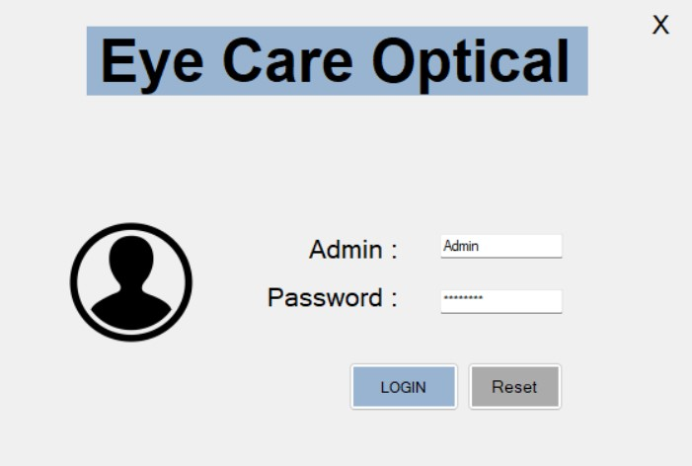

Patient page:

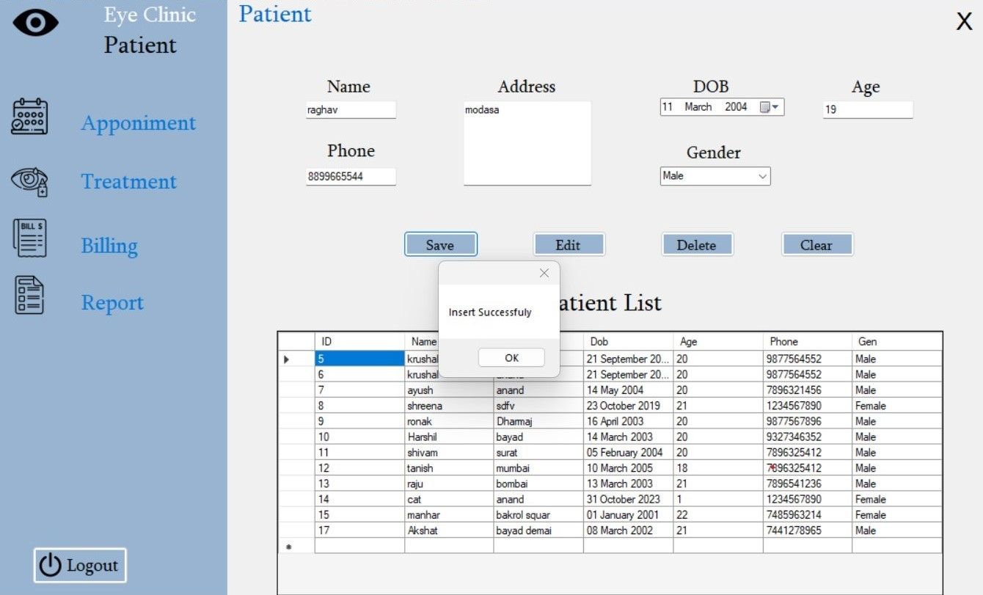

* This page is patient Information form
* This is Store the patient detail’s and it has edit and delete.

Treatment page:

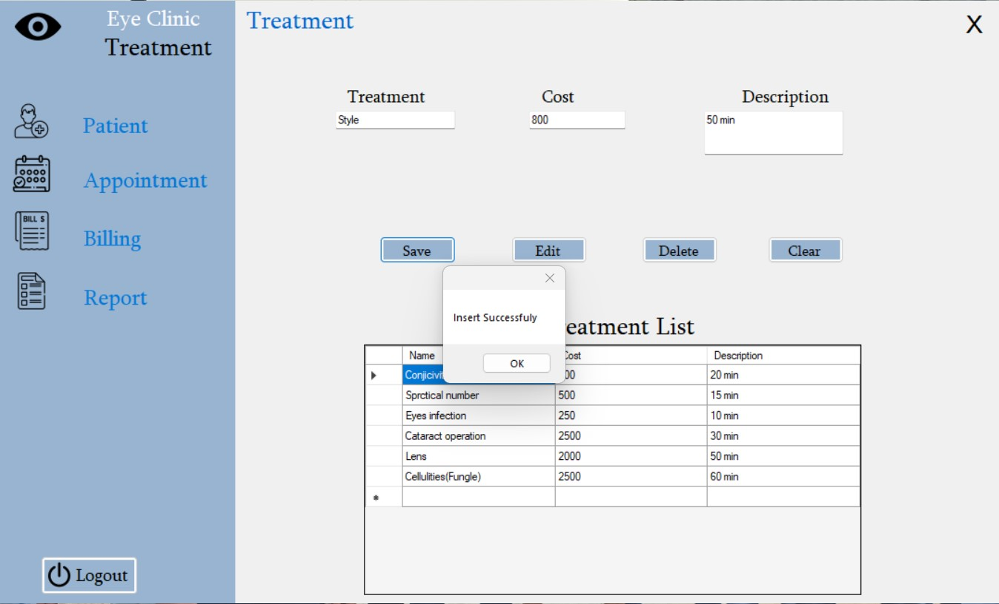

* This page is treatment form
* This is Store the Treatment detail’s and we can edit the cost and delete the details.

Appointment page:

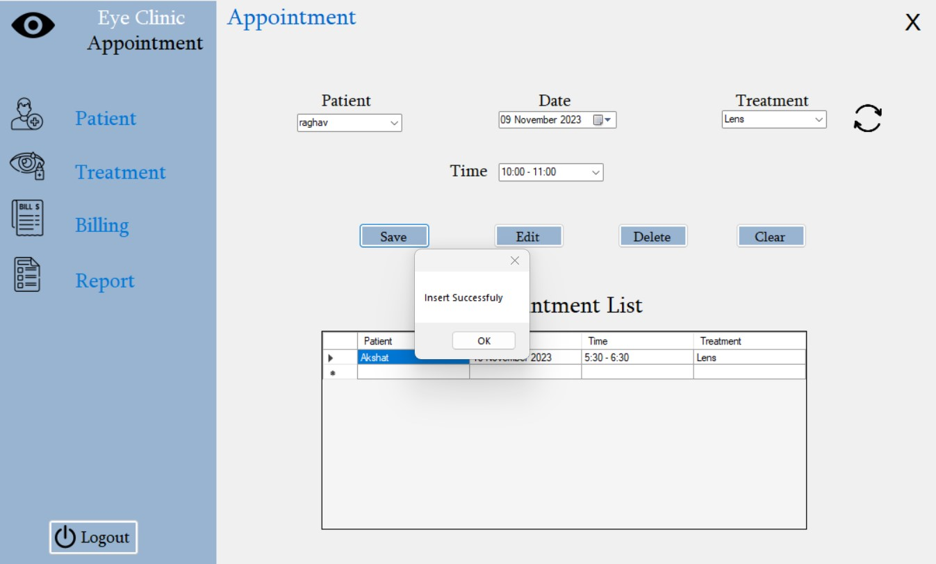

* This page is appointment form.
* This is Store the Appointment detail’s and we can edit the Time, Date.

Billing Form:

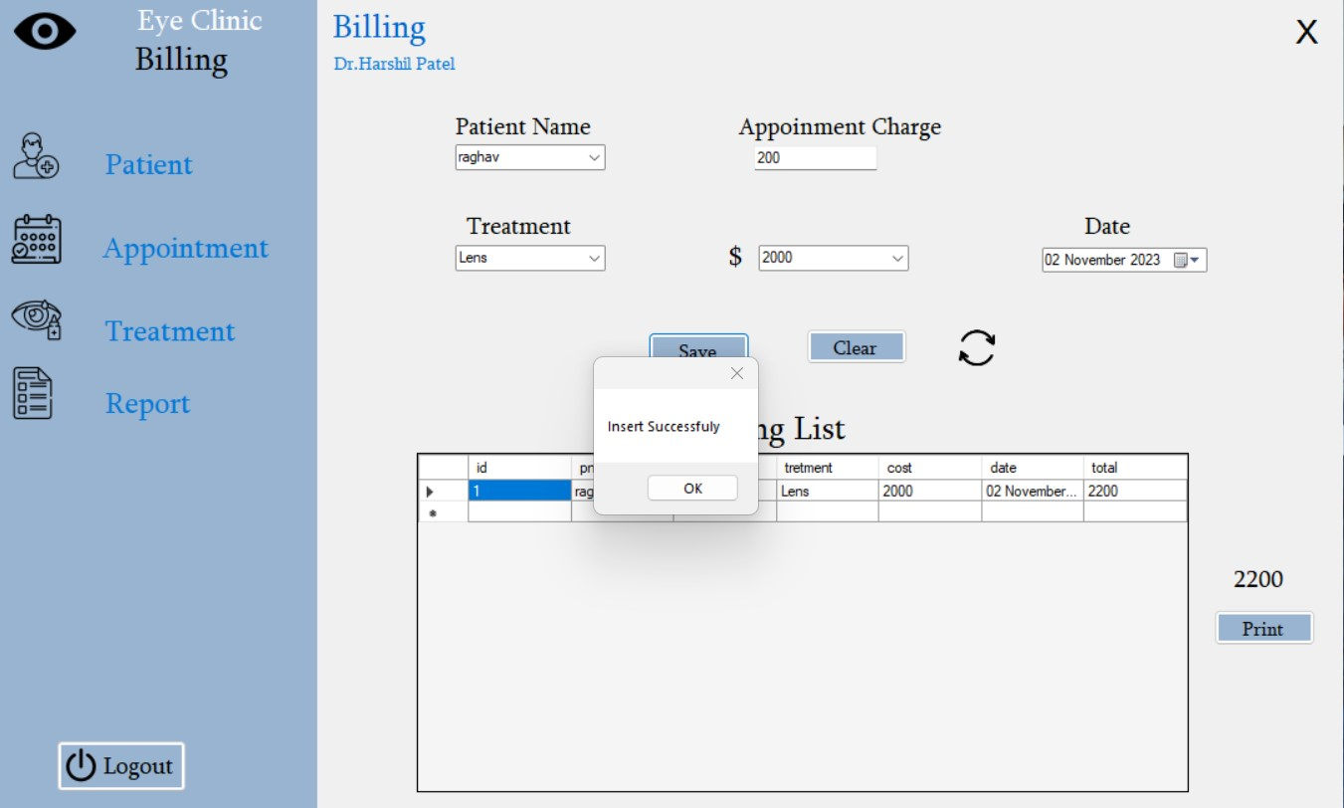

* This page is billing form.
* This is Store the Billing detail’s and we can generate the bill in PDF format.

Print Bill:

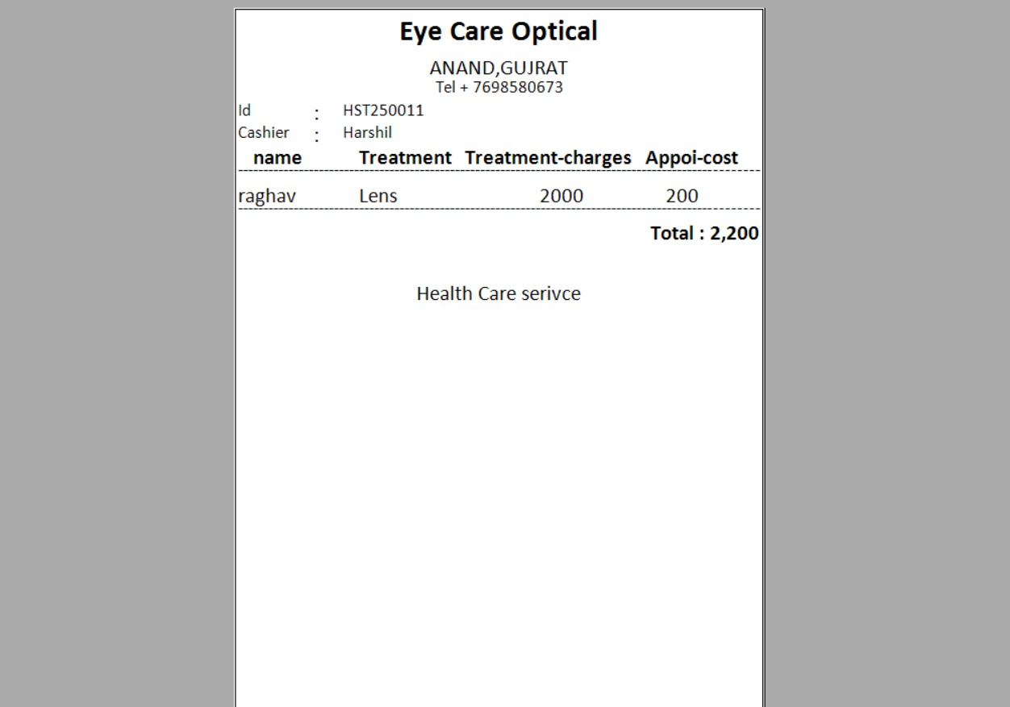

* Billing Report is converting to PDF Format.
* Only Admin can convert the report in PDF Format.

Report Form:

* Patient report: -

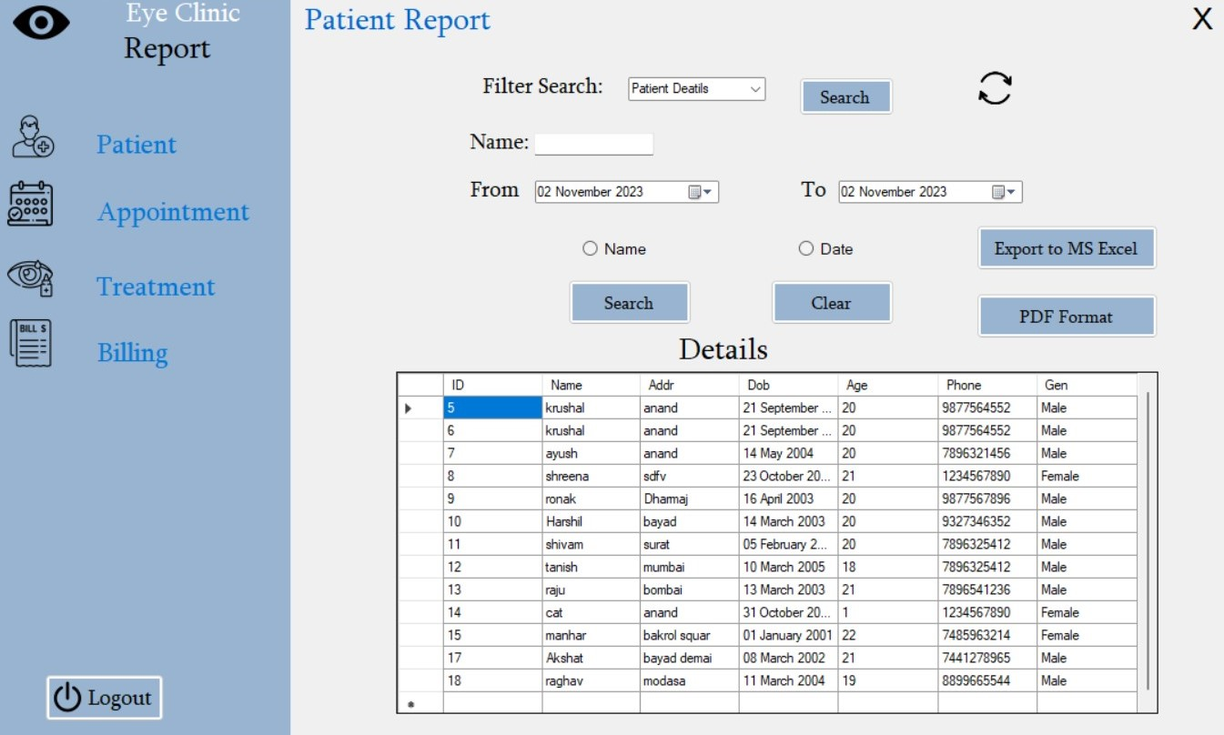

* This page is patient report form.
* To find Patient detail’s and it can search by Name and Date wise then it has also converted into pdf and excel format.
* Patient report in PDF form: -

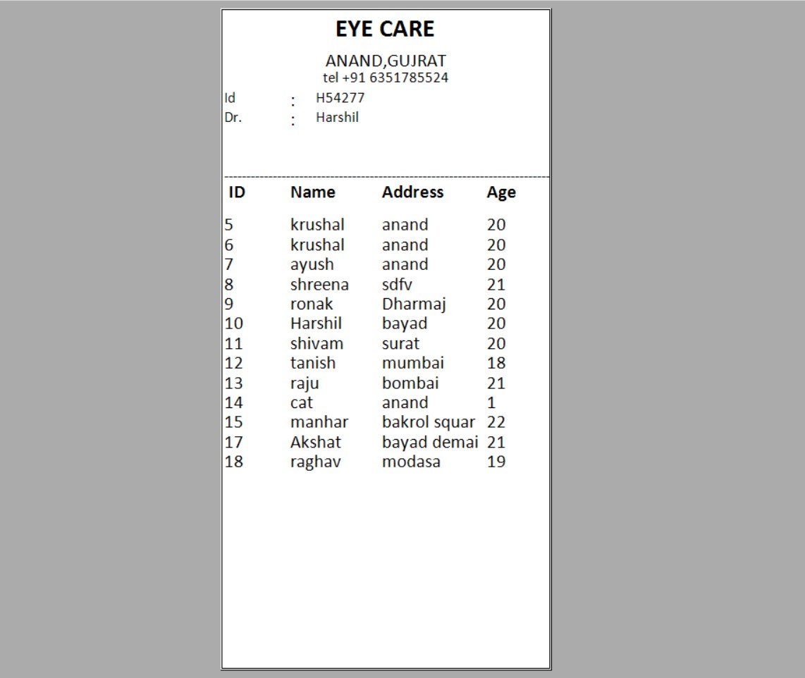

* Patient Report is converting to PDF Format.
* Only Admin can convert the report in PDF Format.
* Patient Report in Excel Format:

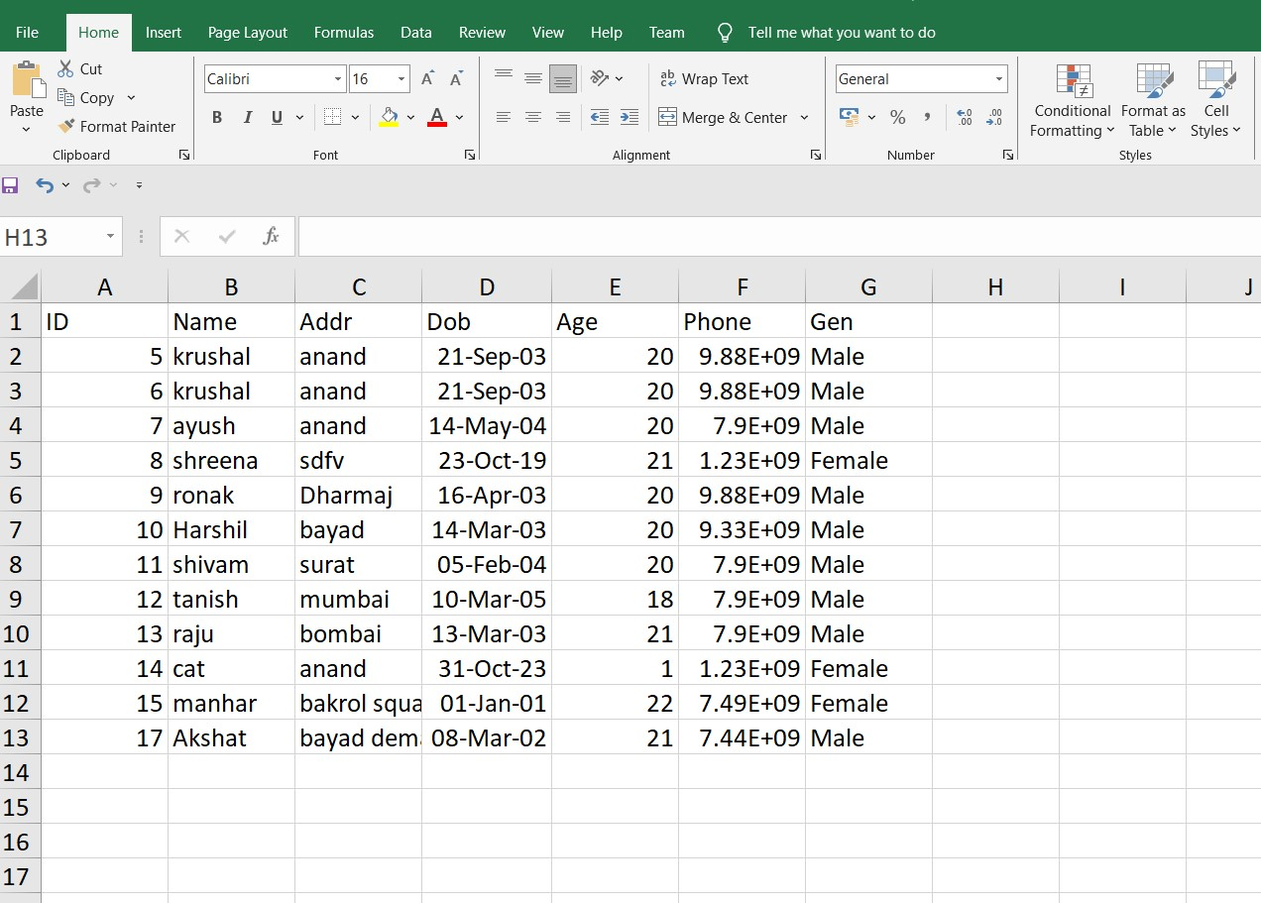

* Patient Detail Report is converting to Excel Format.
* Only Admin can convert the report in Excel Format.
* Appointment report:

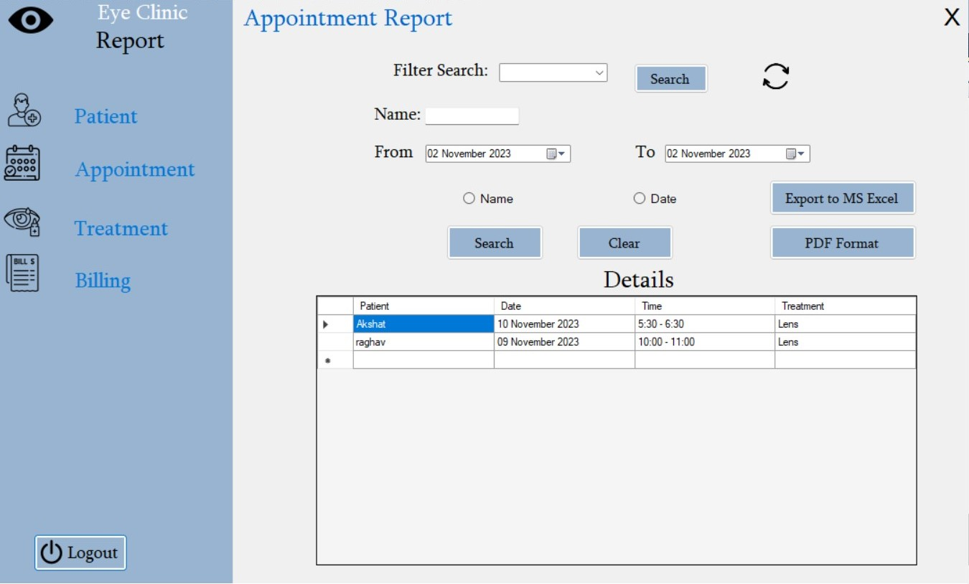

* This page is Appointment report form.
* To find Appointment detail’s and it can search by Name and Date wise then it has also converted into pdf and excel format.
* Appointment Report in PDF Format:

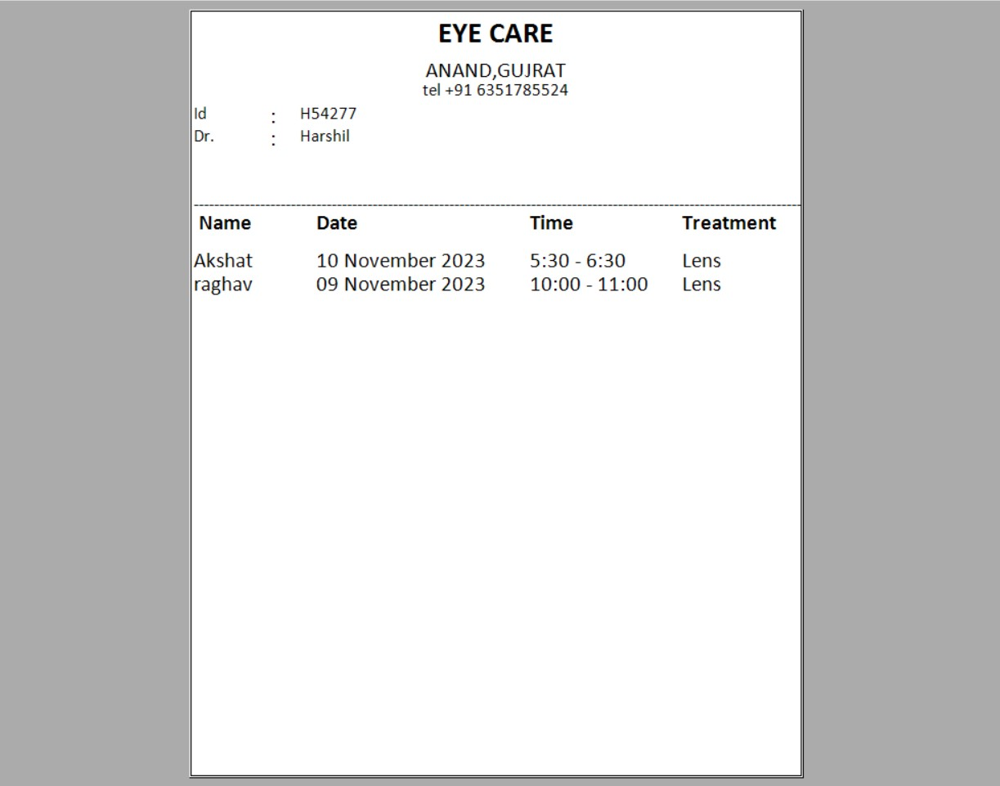

* Appointment Report is converting to PDF Format.
* Only Admin can convert the report in PDF Format.
* Appointment Report in Excel Format:

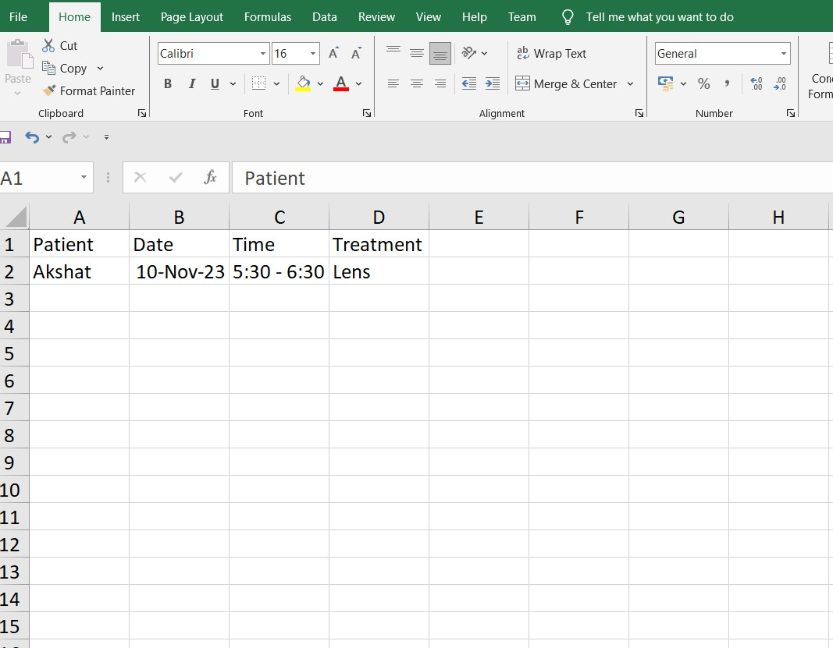

* Appointment Detail Report is converting to Excel Format.
* Only Admin can convert the report in Excel Format.
* Treatment Report:

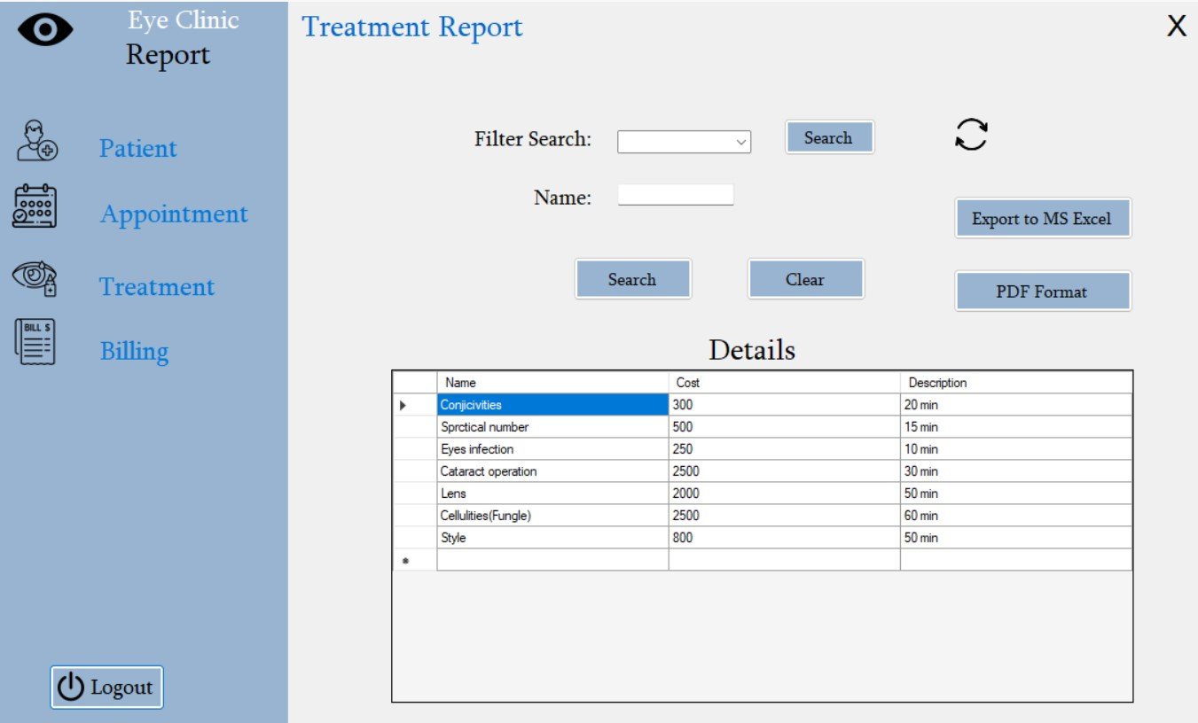

* This page is Treatment report form
* To find Treatment detail’s and it can search by Name and Date wise then it has also converted into pdf and excel format.
* Treatment Report in PDF Format:

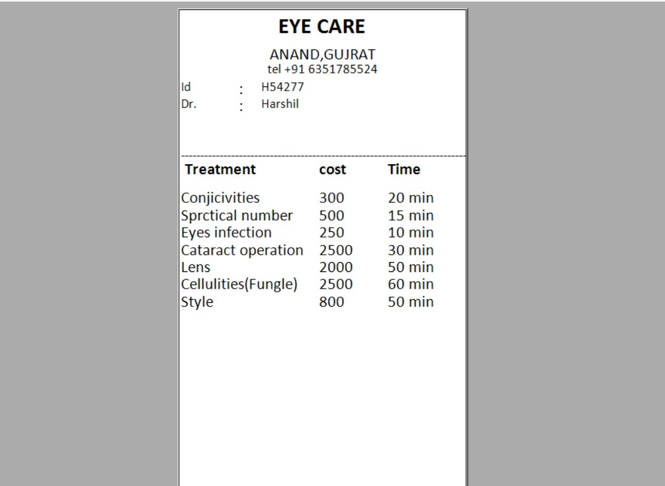

* Treatment Report is converting to PDF Format.
* Only Admin can convert the report in PDF Format
* Treatment Report in Excel Format:

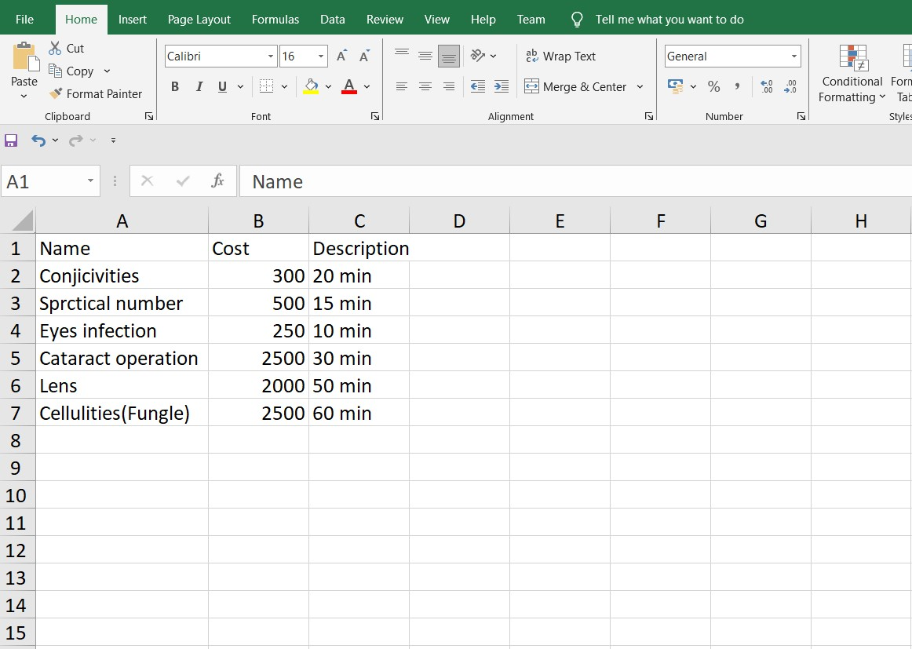

* Treatment Detail Report is converting to Excel Format.
* Only Admin can convert the report in Excel Format.
* Billing Report:

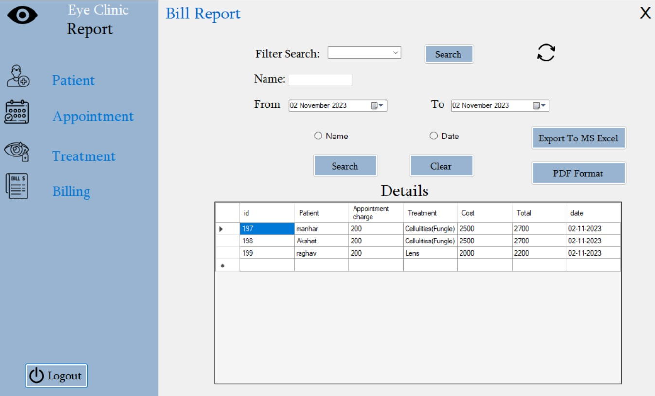

* This page is Billing report form
* To find Billing detail’s and it can search by Name and Date wise then it has also converted into pdf and excel format.
* Billing Report in PDF Format:

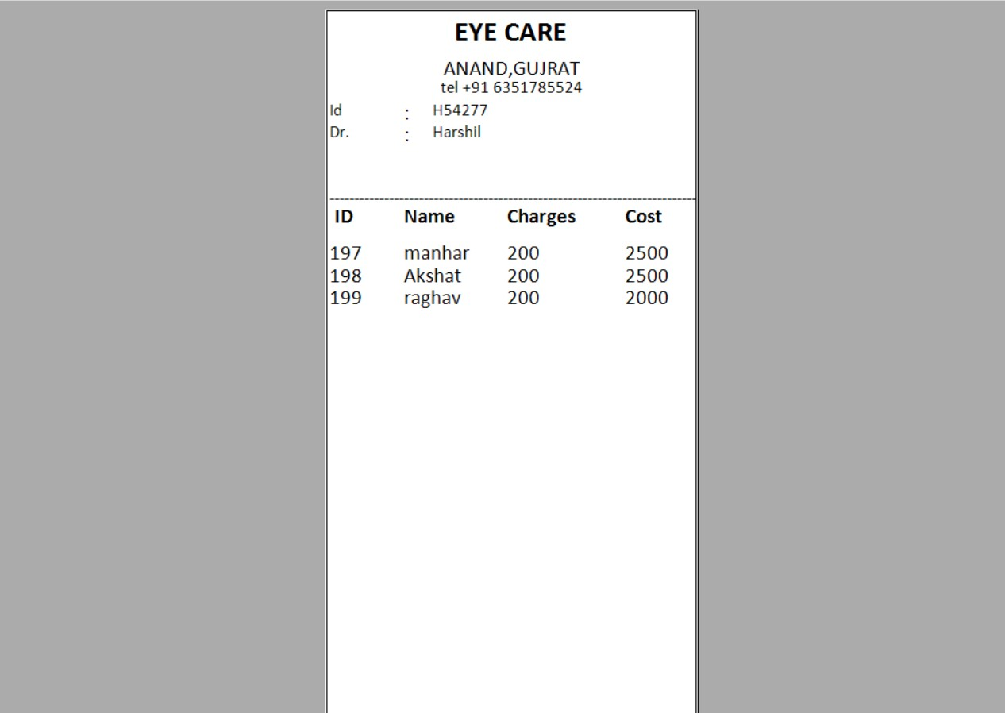

* Billing Report is converting to PDF Format.
* Only Admin can convert the report in PDF Format
* Billing Report in Excel Format:

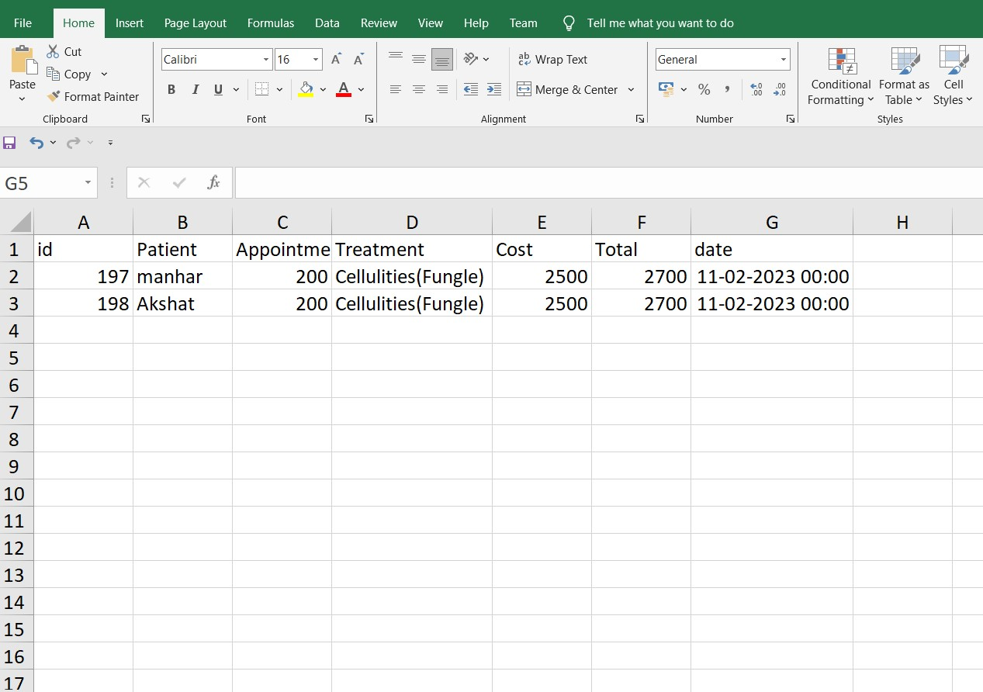

* Billing Detail Report is converting to Excel Format.
* Only Admin can convert the report in Excel Format.